***IMPORTANT DETAILS ABOUT SQL DATABASES***  
  
**You have to create 2 sql data bases:**  
  
**1. Users**

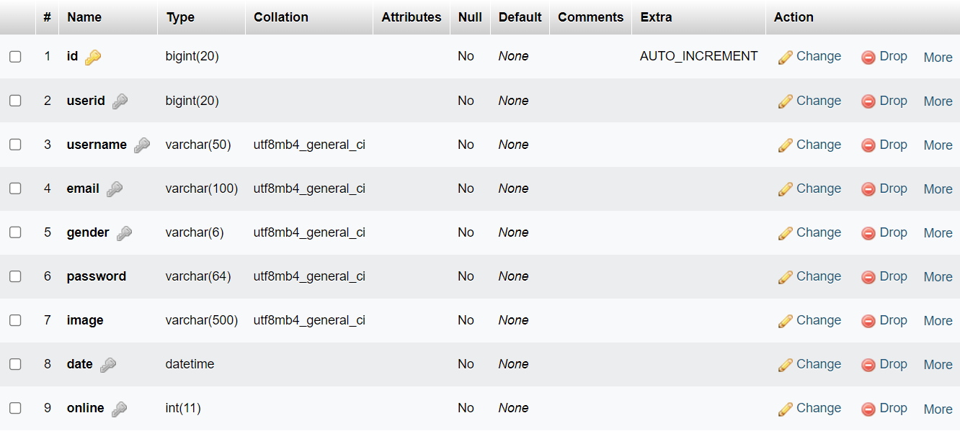

**2. Messages**

